**Assignment -2**

Python Programming

|  |  |
| --- | --- |
| Assignment Date | 29 September 2022 |
| Student Name | Ms. S.Sabnam Shajitha |
| Student Roll Number | 960219104087 |
| Maximum Marks | 2 Marks |

**Question-1:**

Build a python code .Assume you get temperature and humidity values( generated with random function to a variable ) and write a condition to continuously detect alarm in case of high temperature.

|  |
| --- |
| **Solution:** |

**PROGRAM CODE:**

import random

temperature=random.randint(1,100)

humidity=random.randint(1,50)

print(temperature)

print(humidity)

if((temperature<45)&(humidity45)&(humidity35)):

print("Temperature is low")

print("Humidity is high")

elif((temperature>45)&(humidity>35)):

print("Temperature is high")

print("Humidity is high")

else:

print("Temperature is very low")

print("Humidity is very low")

print("Alarm off")

**PROGRAM:**

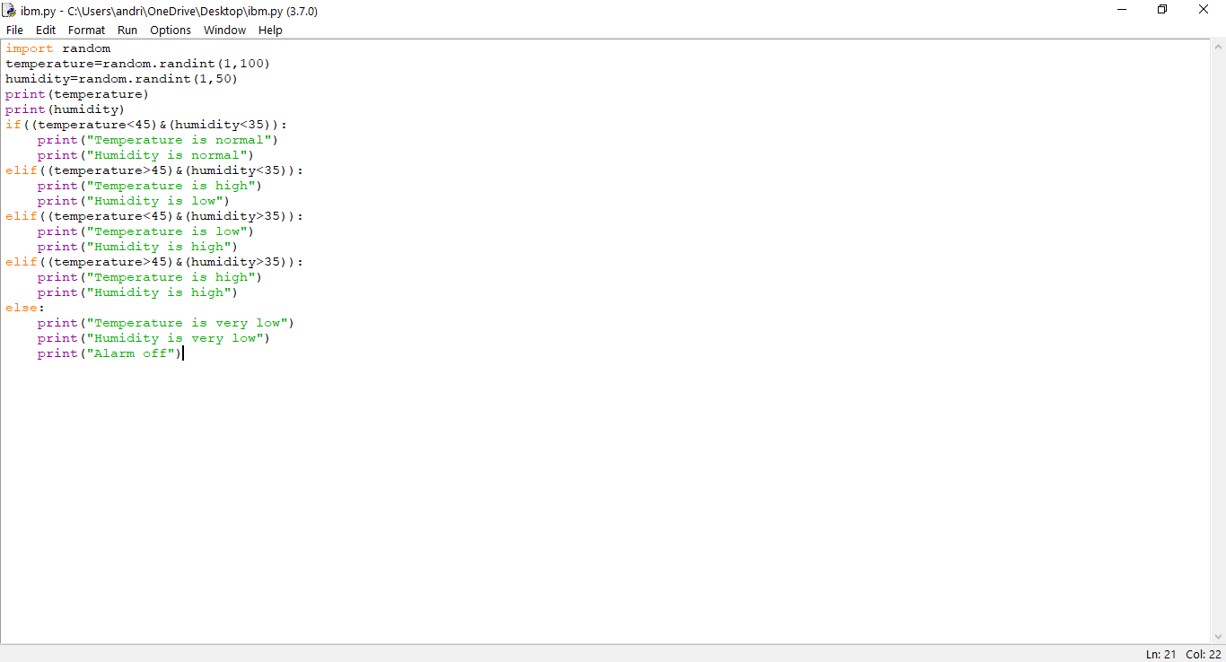

**OUTPUT:**

